Project Synopsis
On
FARM CONNECT: PATHWAY TO PROGRESS
Submitted to Rashtrasant Tukadoji Maharaj Nagpur University, Nagpur in partial fulfillment of requirement for the award of the degree of
BACHELOR OF TECHNOLOGY
In
Computer Science & Engineering

Submitted By
Marshal Alone | Vaishnavi Getme
Aditya Kawale | Sanskruti Patil
Mrunali Umak

Under the Guidance of
Prof. Tejas Dhule
Assistant Professor



Department of Computer Science & Engineering
NAGPUR INSTITUTE OF TECHNOLOGY
Mahurzari, Katol Road Nagpur-441501
Rashtrasant Tukadoji Maharaj Nagpur University, Nagpur
2025-2026

CONTENTS

 | Title | Page No.
 | Declaration | I
 | Vision, Mission, PSO & PEO | II
 | Program Outcomes | III
 | Course Outcomes | IV
 | Abstract | V
1 | INTRODUCTION | 1
2 | LITERATURE SURVEY REVIEW | 4
3 | PROJECT OBJECTIVES | 9
4 | PROBLEM FORMULATION | 10
4 | 4.1 Existing System
4 | 4.2 Proposed system
5 | RESEARCH METHODOLOGY & PROPOSED SOLUTION | 12
6 | RESULT | 31
7 | FACILITIES REQUIRED | 35
8 | PLAN OF WORK | 38
9 | REFERENCES | 39
10 | SIGN | 41


NAGPUR INSTITUTE OF TECHNOLOGY
(Affiliated to RTM Nagpur University & Approved by AICTE New Delhi)
Campus: 13/2, Mahurzari, Near Fetri, Katol Road, Nagpur-441501, India
Email Id : registrar@nit.edu.in Web : www.nit.edu.in Contact No. 9764974144

NAAC “A” Accredited | AICTE ID: 1-4830701 | DTE Code:04144 | RTMNU Code: 315 | AISHE Code: C-18725

Department of Computer Science & Engineering
-----------------------------------------------------------------------------------------------------

DECLARATION

We hereby declare that the Project Report entitled farm Connect:Pathway To Progress submitted here in has been carried out by us in the Department of Computer Science & Engineering at Nagpur Institute of Technology, Nagpur. The presented work is original and has not been submitted earlier as a whole or in part for the award of any degree / diploma at this or any other Institution / University.

We also hereby assign to the Department of Computer Science & Engineering of Nagpur Institute of Technology, Nagpur all rights under copyright that may exist in and to the above work and any revised or expanded derivatives works based on the work as mentioned. Other work copied from references, manuals, etc. are disclaimed.

Sr. No. | Name of the Students | Signature
1 | Marshal Alone
2 | Vaishnavi Getme
3 | Aditya Kawale
4 | Sanskruti Patil
5 | Mrunali Umak

Date:- / /

I

NAGPUR INSTITUTE OF TECHNOLOGY
(Affiliated to RTM Nagpur University & Approved by AICTE New Delhi)
Campus: 13/2, Mahurzari, Near Fetri, Katol Road, Nagpur-441501, India
Email Id : registrar@nit.edu.in Web : www.nit.edu.in Contact No. 9764974144

NAAC “A” Accredited | AICTE ID: 1-4830701 | DTE Code:04144 | RTMNU Code: 315 | AISHE Code: C-18725

Department of Computer Science & Engineering
-----------------------------------------------------------------------------------------------------
Vision of the Institute:
Service to the Society by creating Technical & Skilled Manpower through value based Technical Education.

Mission of the Institute:
- To provide quality technical Education to meet the requirement of industries and society.
- To equip students with need based technical skills through continual improvement in Teaching Learning Processes and research activity.
- To inculcate ethical values for overall holistic development of students.
Vision of the Department:
To foster Computer Science and Engineering graduates by imparting quality technical education through need-based technical skills with ethical values.
Mission of the Department
- To provide quality initiatives in the skill-based teaching learning process to improve technical knowledge in Computer Science and Engineering.
- To enhance intellectual capital of stakeholders by providing research and innovation avenues and improved industry interactions.
- To increase societal, connect for need-based problems through extra-curricular activities.
Program Specific Outcomes (PSO):
- PSO-1: To demonstrate knowledge and understanding of CS engineering concepts and apply these to the industries.
- PSO-2: The ability to understand, analyze and develop computer programs in the areas related to algorithms, system software, multimedia, web design, big data analytics, and networking for efficient design of computer-based systems of varying complexity.
- PSO-3: The ability to employ modern computer languages, environments, and platforms in creating innovative career paths to be an entrepreneur, and a zest for higher studies.
Program Educational Objectives (PEO):
- PEO1: Graduates will pursue successful careers as software professionals, IT consultants and system administrators.
- PEO2: Graduates will adapt to the changing technologies, tools, and societal requirements.
- PEO3: To create and sustain a community of learning in which students acquire knowledge and apply in their concerned fields with due consideration for ethical, ecological, and economic issues.

II
NAGPUR INSTITUTE OF TECHNOLOGY
(Affiliated to RTM Nagpur University & Approved by AICTE New Delhi)
Campus: 13/2, Mahurzari, Near Fetri, Katol Road, Nagpur-441501, India
Email Id : registrar@nit.edu.in Web : www.nit.edu.in Contact No. 9764974144

NAAC “A” Accredited | AICTE ID: 1-4830701 | DTE Code:04144 | RTMNU Code: 315 | AISHE Code: C-18725

Department of Computer Science & Engineering
-----------------------------------------------------------------------------------------------------

Program Outcomes (UG)
- PO1. Engineering knowledge: Apply the knowledge of mathematics, science, engineering fundamentals, and an engineering specialization to the solution of complex engineering problems.
- PO2. Problem analysis: Identify, formulate and analyze real world problems to reach substantial conclusions using computer science and engineering concepts.
- PO3. Design/development of solutions: Design a system component and process to meet desired needs.
- PO4. Conduct problem investigations: use research based knowledge and methods including design, interpretation of data, analysis & synthesis of the information to provide valid conclusion.
- PO5. Modern tool usage: apply appropriate techniques, resources, and modern engineering and IT tools including prediction and modeling to complex engineering activities with an understanding of the limitations.
- PO6. The engineer, industry and society: communicate effectively both in written & oral formats.
- PO7. Environment and sustainability: Understand the impact of the professional engineering solutions in societal and environmental contexts.
- PO8. Ethics: Demonstrate professional skills and ethics .
- PO9. Individual and team work: Function effectively as an individual, and as a member or leader in diverse teams, and in multidisciplinary settings.
- PO10. Communication: Ability to communicate effectively with peer community and society on complex software/system engineering activities through unambiguous spoken language, written reports, presentations.
- PO11. Project management and finance: Ability to apply the knowledge of Engineering and Management principles to manage projects as a team member or leader in multidisciplinary teams.
- PO12. Life-long learning: Recognize the need for, and have the preparation and ability to engage in independent and life-long learning in the broadest context of technological change.

III

NAGPUR INSTITUTE OF TECHNOLOGY
(Affiliated to RTM Nagpur University & Approved by AICTE New Delhi)
Campus: 13/2, Mahurzari, Near Fetri, Katol Road, Nagpur-441501, India
Email Id : registrar@nit.edu.in Web : www.nit.edu.in Contact No. 9764974144

NAAC “A” Accredited | AICTE ID: 1-4830701 | DTE Code:04144 | RTMNU Code: 315 | AISHE Code: C-18725

Department of Computer Science & Engineering
-----------------------------------------------------------------------------------------------------
YEAR/SEM: IV/VIII COURSE NAME: PROJECT COURSE CODE: BTECHCSE705T

BTECHCSE705T | PROJECT
 | After studying the course, the students will be able to
CO1 | To display the working knowledge and skills to the industry.
CO2 | Deeper knowledge of methods in major fields of study.
CO3 | Collection To gain a consciousness of ethical aspects of research and development work.
CO4 | Capability to plan and use adequate methods to conduct qualified tasks  in given frameworks and evaluate the work.

IV

ABSTRACT

Farm Connect: Pathway to Progress is a comprehensive, multi-functional agricultural support system developed to empower farmers through the integration of technology into rural development. The project addresses critical challenges faced by farming communities, particularly the lack of timely information, limited market access, and difficulties in availing government schemes, loans, and machinery. By offering real-time data, direct market linkages, and early warning alerts, Farm Connect seeks to bridge the information and accessibility gap that often hinders agricultural productivity and farmer welfare.

The system has been designed with a strong user-centric approach, incorporating multilingual support and voice input features to ensure inclusivity for farmers with limited literacy or technological skills. Its modular architecture allows each component—such as disease detection, market access, government scheme integration, and weather alert systems—to be developed, tested, and validated individually before being integrated into the full platform.

Key Features of Farm Connect:
- AI-Powered Disease Detection: Image analysis using configurable AI providers (Groq LLM by & Google Gemini Vision AI) to analyze crop images and provide disease identification, severity assessment, and treatment recommendations
- Smart Weather Dashboard: Real-time weather forecasting with agricultural insights and farming alerts
- Machinery Marketplace: Platform for farmers to rent and share agricultural equipment
- Government Schemes Portal: Consolidated information on subsidies, loans, and support programs
- Voice-Enabled Interface: Multilingual voice assistant for farmers with limited literacy
- AI-Powered Chatbot (Voice & Text): Interactive farming assistant where farmers can ask queries via voice input OR text chat in 5 regional languages (Hindi, Marathi, Malayalam, Punjabi, English). Features include speech recognition and text-to-speech output for accessibility;
AI responses use Groq LLM by default (Gemini is also supported).
- User Profile: Personal dashboard for managing bookings and preferences

The platform is built using modern web technologies (React.js, Node.js, MongoDB) ensuring scalability, responsiveness, and cross-platform accessibility.

Keywords: Agriculture, AI Disease Detection, Real-time Weather, Machinery Rental, Government Schemes, Voice Interface, Rural Development, Technology Integration

V

INTRODUCTION
  - Background
Agriculture continues to be a foundational pillar of emerging economies such as India, where a substantial proportion of the population—approximately 58%—depends on farming as its primary source of livelihood. Despite the sector's importance, farmers—especially small and marginal cultivators—face persistent challenges in accessing timely and reliable information related to crop management, weather changes, market prices, and government support services. Traditional information-dissemination channels remain slow, fragmented, and often inaccessible due to language barriers and limited digital exposure. With the rapid expansion of mobile connectivity and digital infrastructure in rural regions, there is a significant opportunity to leverage technology to bridge these longstanding gaps. The Indian government's Digital India initiative and the proliferation of affordable smartphones have created an environment conducive to technology-driven agricultural solutions.
  - Motivation
The motivation for developing Farm Connect stems from several critical observations:
- Information Asymmetry: Farmers often lack access to real-time market prices, leading to exploitation by middlemen and reduced profit margins.
- Disease Management Challenges: Delayed disease identification results in crop losses averaging 15-25% annually. Early detection through AI can significantly reduce these losses.
- Underutilization of Government Schemes: Despite numerous agricultural support programs, awareness and accessibility remain low among rural farmers.
- Weather Vulnerability: Unpredictable weather patterns and lack of timely alerts contribute to crop failures and financial losses.
- Equipment Access Barriers: High costs of agricultural machinery prevent small farmers from modernizing their practices.

1

  - Need for Farm Connect
In response to these needs, the proposed system Farm Connect: Pathway to Progress seeks to provide a comprehensive, user-friendly, and regionally adaptable digital platform designed specifically for Indian farmers. The platform aims to integrate:
- Real-time weather updates with agricultural insights
- AI-powered pest and disease detection and alerts
- User profile and booking management
- Government schemes and subsidy information
- Agricultural machinery rental marketplace
- Voice-enabled multilingual interface

1.4 Theoretical Foundation
The theoretical foundation of this research draws upon established frameworks such as:
- Diffusion of Innovations Theory (Rogers, 2003): Explains technology adoption patterns and how innovations spread through social systems.
- Technology Acceptance Model (TAM): Focuses on perceived usefulness and ease of use as primary determinants of technology adoption.
- Information Systems Success Model (DeLone & McLean): Emphasizes system quality, information quality, and service quality as key factors in system success.
- Socio-Technical Systems Theory: Underlines the importance of alignment between technology and users' cultural and social environments.
These models collectively guide the design, implementation, and evaluation of Farm Connect.

2

  - Scope of the Project

The scope of Farm Connect encompasses:

- AI-Powered Disease Detection Module: Image analysis using configurable AI providers (Groq LLM by default; optionally Google Gemini Vision AI)
- Smart Weather Dashboard: Integration with WeatherAPI for real-time forecasting
- Machinery Marketplace: Peer-to-peer equipment rental platform
- Government Schemes Portal: Database of agricultural subsidies and support programs
- User Profile: Personal dashboard with booking history and preferences
- AI Chatbot (Voice & Text): Multilingual assistant supporting Hindi, Marathi, Malayalam, Punjabi, and English - farmers can ask questions via voice or text input, with AI-powered responses from Groq LLM by default (Google Gemini is also supported) and text-to-speech output
- User Authentication: Secure login system with JWT token authentication

3

2. LITERATURE SURVEY

1.Patil & Deshmukh (2021) – Smart Agriculture System Using IoT
Patil and Deshmukh present an IoT-based smart agriculture framework that uses sensors to monitor soil moisture, temperature, humidity, and environmental conditions. Their study highlights how real-time data collection and automated alerts enable farmers to take timely decisions, improving crop health and reducing resource wastage. The system demonstrates how IoT can reduce labour dependency while supporting precision farming practices. The paper also identifies common barriers such as cost, connectivity issues, and sensor calibration. This study is relevant to Farm Connect as it supports real-time monitoring, advisory generation, and the integration of low-cost IoT solutions in digital agriculture platforms.

2. Rao & Kumar (2022) – Smart Agriculture Monitoring with Low-Cost Sensors
Rao and Kumar’s work focuses on creating a cost-effective agricultural monitoring system using affordable sensors and microcontrollers. Their research demonstrates that even smallholder farmers can benefit from digital tools when designed with affordability and simplicity in mind. By integrating sensors like DHT11 and soil moisture probes, the system automates irrigation decisions and provides continuous environmental updates. The study also emphasizes data accuracy, ease of deployment, and resource optimization. This directly supports Farm Connect’s objective of enabling accessible digital monitoring, reinforcing the possibility of scalable solutions for small- and marginal-farmer communities.

3. Ministry of Agriculture (2020) – eNAM: Transforming Agricultural Markets
The Government of India’s eNAM report evaluates the impact of digital marketplaces on agricultural trade. It highlights how eNAM improves transparency, market competitiveness, and access to national buyers, reducing dependence on middlemen. The report identifies operational constraints such as inadequate grading, digital literacy gaps, and infrastructural limitations. Despite these challenges, eNAM has significantly enhanced price realization for participating farmers. This literature is important for Farm Connect as it shows the transformative potential of digital marketplaces and emphasizes the need for user-friendly interfaces, training, and seamless integration to support fair and efficient agricultural trade.

4

4. Singh & Mehta (2021) – Mobile Apps for Agricultural Extension in India
Singh and Mehta analyze several mobile applications used in agricultural extension and find common issues such as language barriers, fragmented data, poor interface design, and inconsistent content quality. Their study reveals that farmers tend to abandon apps that lack clarity, reliability, or local-language support. They emphasize that for digital tools to succeed, they must provide region-specific advisories, simple navigation, and clear visual aids. The paper supports the idea that technology should adapt to user limitations rather than expecting rural farmers to adapt to complicated systems. This directly strengthens Farm Connect’s focus on inclusive, local-language, user-centered design.

5. Kumar & Verma (2022) – Mobile-Based Agricultural Extension Services
Kumar and Verma assess the adoption and impact of mobile-based extension services across Indian farming communities. Their results indicate that mobile advisories significantly improve farmers’ knowledge and decision-making related to crop management, input selection, and risk mitigation. The study identifies trust, clarity of information, and source credibility as the strongest determinants of adoption. Farmers who receive regular, actionable, and localized suggestions show measurable improvements in productivity. The authors also stress the importance of two-way communication between farmers and extension officers. These insights guide Farm Connect in designing reliable, trustworthy advisory modules supported by credible data sources and expert validation.

6. Google Research Team (2019) – Voice Access for the Next Billion Users
The Google Research report studies voice interface adoption among low-literacy users in developing regions. It highlights that voice technology significantly reduces barriers to digital engagement by offering a natural, intuitive mode of interaction. However, challenges remain, particularly in handling diverse accents, dialect variations, contextual understanding, and noisy environments. The study recommends building region-specific speech models and designing simple, structured conversational flows. These findings are crucial to Farm Connect, which aims to serve semi-literate farmers through voice-enabled navigation, content retrieval, and advisory access, ensuring accessibility even for individuals unfamiliar with smartphones or text-based interfaces.

5

7. Medhi, Sagar & Toyama (2011) – Text-Free User Interfaces
This study explores the effectiveness of text-free user interfaces for low-literate populations, demonstrating how icons, visuals, and guided navigation can dramatically improve usability. The authors identify limitations of text-heavy systems and show how intuitive visual layouts reduce cognitive load and support independent use. The research recommends using culturally relevant icons, audio cues, and minimal text to enhance comprehension. These insights are directly applicable to Farm Connect, which intends to incorporate icon-based navigation and voice instructions for easier app usage in rural areas. The findings support the need for multimodal interfaces combining text, visuals, and speech.

8. Hansen & Coffey (2020) – Climate Information for Agricultural Risk Management
Hansen and Coffey emphasize the importance of integrating weather forecasts, climate predictions, and advisory systems to mitigate agricultural risks. Their study examines how timely, localized weather information helps farmers plan irrigation, fertilizer use, and pest control strategies. They highlight the need for accurate downscaling of regional forecasts to local farm-level conditions. The research also discusses the challenges of communicating scientific data in formats farmers can easily understand. These insights support Farm Connect’s real-time weather and early-warning module, ensuring that the information delivered is both accurate and actionable, reducing crop losses and improving farm productivity.

9. Sharma & Rao (2021) – Weather-Based Agro-Advisory Services
Sharma and Rao examine the effectiveness of Weather-Based Agro-Advisory Services (WBAAS) and their role in improving farming outcomes. Their findings show that farmers who regularly receive weather-based recommendations experience fewer losses related to unexpected rainfall, pests, and climatic variability. The study also highlights the importance of localized advisories, delivered through channels like SMS, IVR, and mobile apps. Farmer trust and timely dissemination are key factors influencing adoption. This research validates Farm Connect’s approach of combining real-time forecasts with crop-specific recommendations, delivered through multiple channels to ensure reach across varying literacy and connectivity levels.

6

10. FAO (2021) – Digital Agriculture Transformation in Developing Countries
The Food and Agriculture Organization’s report highlights how digital agriculture solutions such as mobile advisory services, e-markets, and remote sensing are transforming farming in developing nations. The study emphasizes that digital platforms improve productivity, improve supply chain transparency, and enhance farmer resilience to climate risks. However, it also stresses the importance of digital capacity building and gender-inclusive technology access. This report is highly relevant to Farm Connect as it validates the global need for inclusive, farmer-centered digital platforms that integrate advisory, market access, and climate intelligence in a unified ecosystem.

11. Joshi & Kulkarni (2022) – Farmer Adoption of Mobile-Based Advisory Systems
Joshi and Kulkarni analyze behavioral factors influencing farmers’ adoption of mobile advisory services in India. Their findings show that ease of use, trust in information sources, and language compatibility play a crucial role in sustained app usage. The study highlights that farmers prefer platforms that offer localized content, simple visuals, and practical problem-solving features. The authors also observe that peer influence and community promotion significantly accelerate adoption. These findings strongly support Farm Connect’s design philosophy of localized language support, community engagement, and expert-verified advisory systems for higher user trust and long-term adoption

12. Mishra & Tiwari (2020) – Digital Supply Chain Management in Agriculture
Mishra and Tiwari assess the impact of digital supply chain platforms on agricultural logistics and market efficiency. Their study demonstrates that digital integration reduces post-harvest losses, improves price discovery, and enhances coordination between farmers, traders, and transporters. The research highlights the role of real-time data sharing in minimizing delays and market volatility. However, infrastructural constraints and fragmented adoption remain challenges. This study strengthens Farm Connect’s scope of integrating market connectivity, logistics support, and transparent digital trading mechanisms for better farmer profitability.

7

13. Verma & Singh (2021) – Impact of Weather Forecast-Based Decision Support Systems
Verma and Singh evaluate weather forecast-based decision support systems and their influence on farm-level decision-making. Their findings reveal that farmers using predictive weather tools improve crop scheduling, reduce pest damage, and enhance fertilizer efficiency. The study also indicates that acceptance increases when information is delivered in simple language with clear actionable recommendations. The research validates Farm Connect’s weather advisory module by highlighting the importance of transforming complex climate data into simplified, farmer-friendly decision guidance.

14. Choudhary & Jain (2022) – AI-Based Crop Disease Detection Systems
Choudhary and Jain analyze the application of artificial intelligence in crop disease detection using image processing and machine learning models. Their research demonstrates that AI-based systems can accurately identify early-stage crop diseases, enabling timely preventive action. The authors highlight the importance of image quality, dataset diversity, and user-friendly interfaces for effective field deployment. This study directly contributes to Farm Connect’s future AI roadmap, particularly in integrating automated crop health monitoring and disease diagnosis tools for precision farming.

15. Narayanan & Iyer (2021) – Digital Literacy and Rural Technology Adoption
Narayanan and Iyer investigate how digital literacy levels influence technology adoption in rural India. Their findings reveal that lack of basic smartphone skills limits farmers’ ability to utilize advanced digital services. The study stresses the importance of training programs, voice-based systems, and assisted digital onboarding. This literature strongly reinforces Farm Connect’s emphasis on voice interfaces, guided navigation, training content, and digital inclusion strategies to ensure maximum farmer participation and sustainable system adoption.

8

3.PROJECT OBJECTIVES

The primary objectives of the Farm Connect project are designed to address the critical challenges faced by Indian farmers through an integrated digital platform.

3.1 Primary Objectives

To develop an integrated digital platform that connects farmers with essential agricultural resources and services through a single unified interface.

To provide AI-based crop disease detection for improved decision-making using Google Gemini Vision AI with treatment recommendations and prevention strategies.

To deliver real-time weather updates with agricultural insights, farming alerts, and actionable recommendations for irrigation, pest control, and crop protection.

To create a unified platform that integrates all essential agricultural services into a single accessible interface.

To provide a machinery rental marketplace enabling farmers to access agricultural equipment without significant capital investment.

3.2 Secondary Objectives

To include a multilingual, voice-enabled interface to ensure accessibility for farmers of all literacy levels, supporting Hindi, Marathi, Malayalam, Punjabi, and English.

To offer consolidated information on government schemes, subsidies, and agricultural support programs with eligibility checking functionality.

To issue early warning alerts for adverse weather conditions, pest outbreaks, and crop diseases using AI-powered predictive analytics.

To build a secure authentication system with OTP verification for user protection.

To develop a secure, scalable, and user-friendly platform capable of supporting large numbers of rural users with responsive design for mobile accessibility.

3.3 Technical Objectives

To implement a modern tech stack using React.js for frontend, Node.js/Express for backend, and MongoDB for database management.

To integrate third-party APIs including Weather API for weather data, Google Gemini AI for disease detection and farming advice.

To ensure PWA (Progressive Web App) capabilities for one functionality and mobile installation.

To create RESTful API architecture for seamless communication between frontend and backend services

9

4.Problem Formulation

4.1 Existing System
The existing agricultural support system in India suffers from major fragmentation and inaccessibility:

4.1.1 Information Fragmentation
- Government schemes, market prices, and weather updates are available across multiple platforms with no unified source.
- Farmers must navigate numerous websites, apps, and offices to access different services.
- Information is often outdated, inconsistent, or difficult to understand.

4.1.2 Language Barriers
- Most agricultural apps operate primarily in English or Hindi.
- Regional language support is limited or poorly implemented.
- Text-heavy interfaces exclude farmers with limited literacy.

4.1.3 Disease Detection Challenges
- Manual disease identification requires expert knowledge not readily available in rural areas.
- By the time farmers identify diseases, significant crop damage has often occurred.
- Existing solutions require expensive equipment or specialized training.

4.1.4 Market Access Issues
- Farmers depend heavily on middlemen who often exploit information asymmetry.
- Real-time price information is not accessible to most farmers.
- Direct buyer connections are rare for small and marginal farmers.

4.1.5 Equipment Accessibility
- High costs of agricultural machinery prevent modernization.
- No organized platform exists for equipment sharing or rental.
- Underutilization of existing machinery in rural communities.

4.1.6 Government Scheme Awareness
- Low awareness of available subsidies and support programs.
- Complex application processes discourage participation.
- Eligibility criteria are often unclear or difficult to verify.
10
4.2 Proposed System
The proposed system, Farm Connect, aims to address the limitations of current agricultural information platforms by creating a unified, intelligent, and accessible digital ecosystem for farmers.
4.2.1 System Overview
Farm Connect is a responsive web application built using:
- Frontend: React.js with TypeScript, Tailwind CSS, Shadcn/UI components.
- Backend: Node.js with Express.js
- Database: MongoDB for flexible data storage.
- AI Services: Google Gemini AI for disease detection and farming advice.
- Weather API: WeatherAPI.com for real-time weather data.

4.2.2 Core Modules
Module | Description | Key Features
Disease Detection | AI-powered crop disease identification | Image upload, instant analysis, treatment recommendations
Weather Dashboard | Real-time weather with farming insights | 7-day forecast, farming alerts, crop advisory
Machinery Marketplace | Equipment rental platform | Browse, book, review machinery
Government Schemes | Subsidy and scheme information | Search, filter, category browsing, scheme details
Voice Interface | Multilingual voice assistant | Speech recognition, voice responses
User Profile | Personal dashboard | Booking history, saved schemes, preferences

4.2.3 Key Innovations

- Unified Platform: Single interface for all agricultural needs.
- AI-First Approach: AI-based disease detection using Groq and Gemini Vision AI for accurate diagnosis and recommendations.
- Voice Accessibility: Natural language interaction for low-literacy users.
- Real-time Data: Live weather updates with agricultural context.
- Direct Market Access: Peer-to-peer machinery sharing and produce sales.

4.2.4 Expected Benefits

- Reduced crop losses through early disease detection (estimated 15-20% improvement)
- Increased scheme utilization through simplified access
- Reduced equipment costs through sharing economy
- Improved decision-making through weather-based advisory
11

5. RESEARCH METHODOLOGY & PROPOSED SOLUTIONS

The research methodology for Farm Connect follows a systematic and structured approach combining software engineering principles with user-centered design practices.

5.1 Development Methodology
Farm Connect was developed using an Agile Scrum methodology with the following phases:

Phase 1: Requirements Gathering
- Stakeholder interviews with farmers and agricultural experts
- Analysis of existing agricultural applications and their limitations
- Documentation of functional and non-functional requirements

Phase 2: System Design
- Architecture design using modular component-based approach
- Database schema design for MongoDB collections
- API endpoint design for RESTful services
- UI/UX wireframing and prototyping

Phase 3: Iterative Development
- Sprint-based development cycles (2-week sprints)
- Continuous integration and testing
- Regular stakeholder feedback and iteration

Phase 4: Testing & Deployment
- Unit testing and integration testing
- User acceptance testing with target farmers
- Cloud deployment and performance optimization

12
5.2 Data Collection Methods
Method | Purpose | Data Collected
Farmer Surveys | Understanding user needs | Pain points, feature requests, literacy levels
API Integration | Real-time data | Weather data, government scheme information
Literature Review | Best practices | Technology trends, existing solutions

5.3 System Architecture
5.3.1 High-Level Architecture
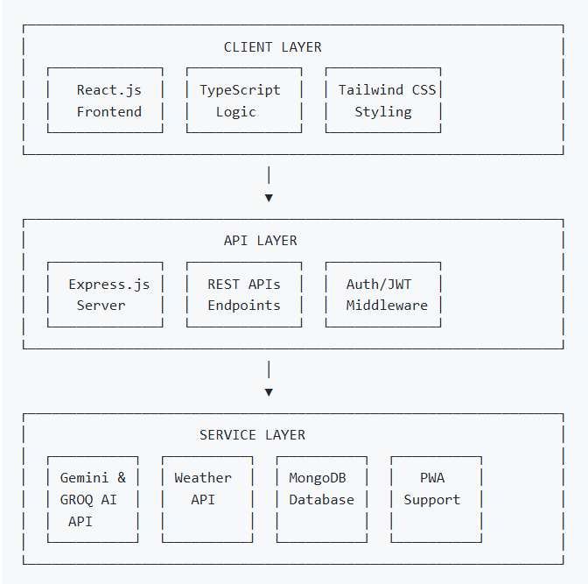
13

5.3.2 Component Architecture

Layer | Components | Technologies
Presentation | Pages, Components, UI Elements | React.js, Shadcn/UI, Lucide Icons
State Management | Context API, React Query | React Context, TanStack Query
Routing | Page Navigation | React Router DOM
API Communication | HTTP Client | Axios, Fetch API
Backend Services | REST APIs | Express.js, Node.js
Database | Data Persistence | MongoDB
External APIs | Third-party Services | WeatherAPI, Groq LLM,Gemini AI

14
5.3.3 Layer-wise Code Implementation
The following code snippets demonstrate the 3-tier architecture implementation:
- CLIENT LAYER (React.js + TypeScript + Tailwind CSS)
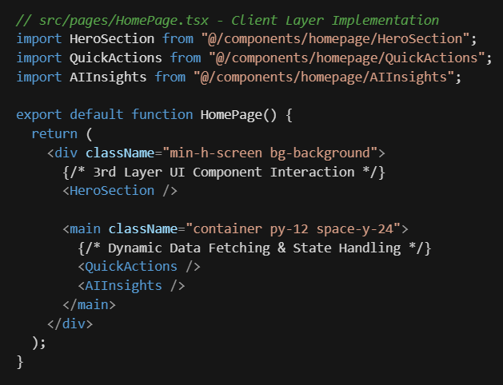

15

- API LAYER (Express.js Server + REST APIs + Auth/JWT Middleware)
Express.js Server Setup:
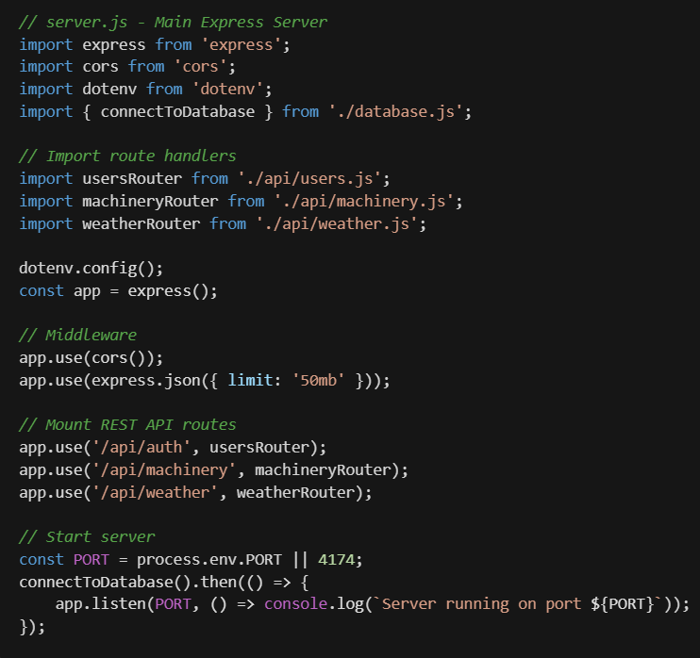
16

Client-Side JWT Storage & API Calls:
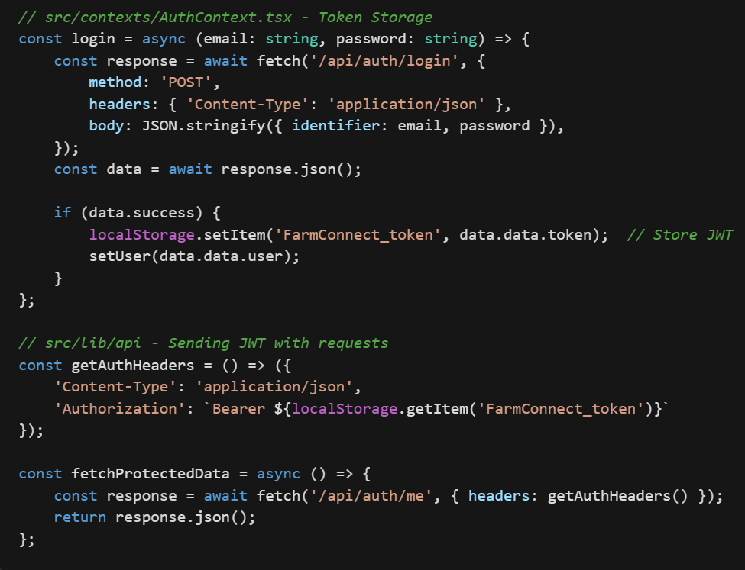

17

- SERVICE LAYER (AI Providers & External Services)
Groq LLM AI Service (Primary):
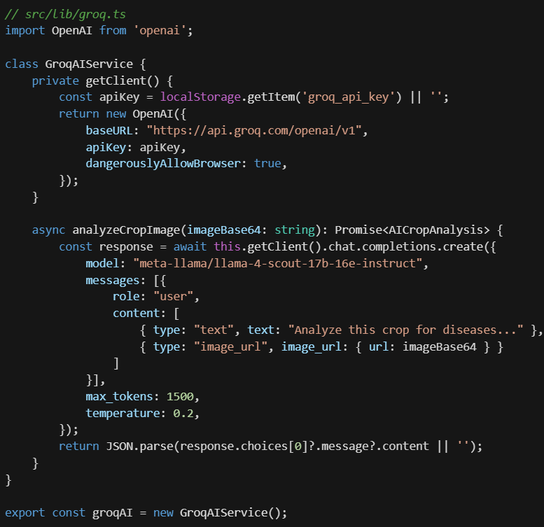

18

Google Gemini AI Service (Alternate):
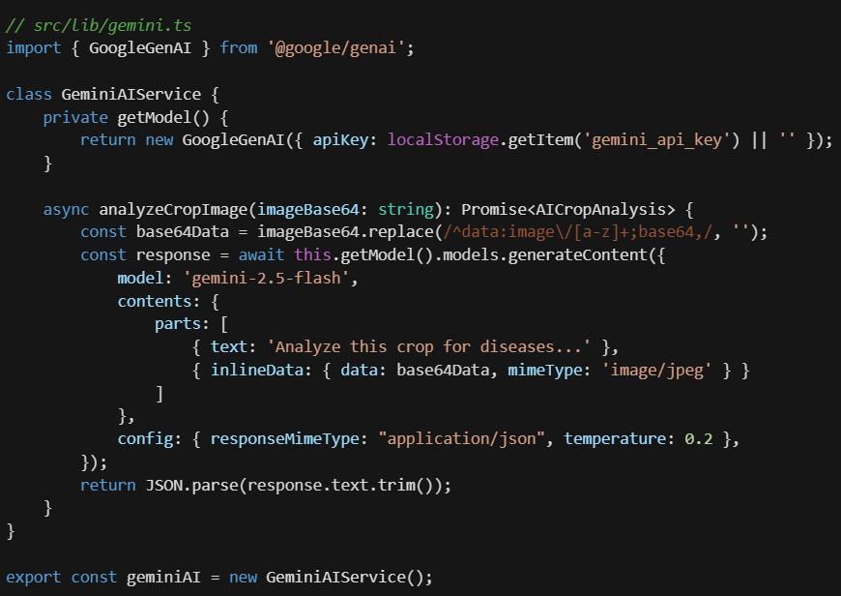

19

Centralized AI Provider (User-Switchable):
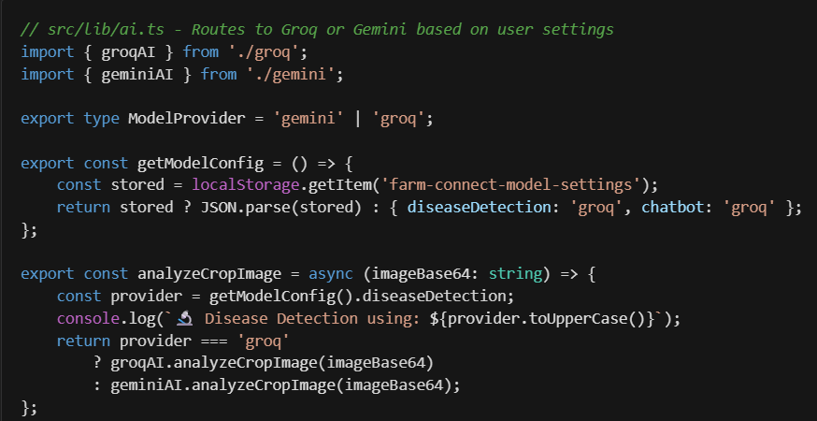
MongoDB Database Connection:
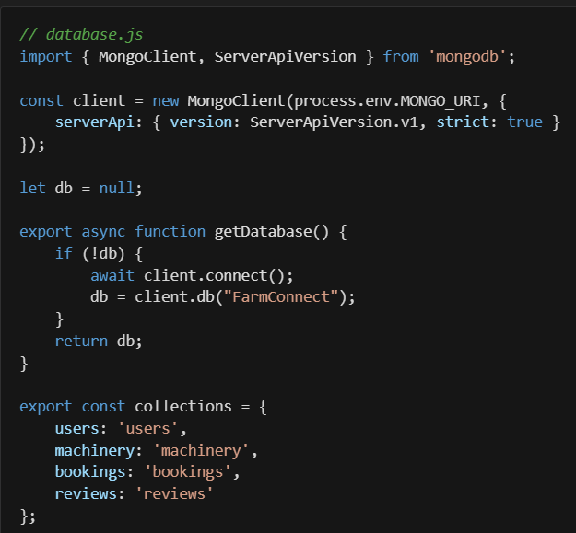
20

PWA Service Worker:
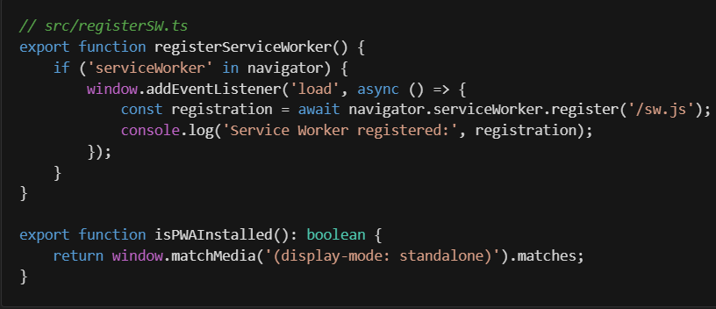
5.4. PROPOSED SOLUTION
5.4.1 AI Disease Detection Module
Technology: Groq LLM and Google Gemini Vision AI (gemini-2.0-flash-exp model)
Process Flow:
1. User uploads crop image via drag-and-drop or file selection.
2. Image is converted to Base64 format.
3. Image sent to Gemini Vision AI with structured prompt.
4. AI analyzes image for diseases and pest infestations.
5. Response includes disease name, confidence, severity, treatment, prevention.
6. Results displayed with visual indicators and actionable recommendations.
Key Features:
- Support for JPEG, PNG, Web image formats
- Detection of both diseases and pest infestations
- India-specific disease and pest database
- Treatment recommendations with locally available solutions
- Detection history stored for user reference

21
5.4.2 Smart Weather Dashboard Module
Technology: WeatherAPI.com integration with AI-powered insights
Features:
- Real-time current weather conditions
- 7-day weather forecast
- Agricultural-specific metrics (humidity, temperature, wind speed)
- AI-generated farming recommendations based on conditions
- City search functionality
- Geolocation-based automatic detection
Data Points Displayed:
Metric | Description | Agricultural Relevance
Temperature | Current temperature | Crop stress indicators
Humidity | Relative humidity % | Disease risk assessment
Wind Speed | km/h | Spraying conditions
Rain Forecast | Chance of rain | Irrigation planning

5.4.3 Machinery Marketplace Module
Features:
- Equipment listing with images and specifications
- Category-based filtering (Tractors, Harvesters, Sprayers, etc.)
- Location-based search
- Booking system with date selection
- Owner dashboard for equipment management
- Review and rating system
- Messaging between farmers and owners

22
Database Collections:
- Machinery : Equipment listings
- bookings : Rental bookings
- reviews : User reviews
- messages : Communication threads

5.4.4 Government Schemes Portal Module
Features:
- Comprehensive database of central and state schemes
- Category filtering (Irrigation, Seeds, Livestock, Credit, etc.)
- State-wise scheme filtering
- Scheme details and benefits display
- Status indicators (Active, Deadline Soon, Closed)

Scheme Categories Covered:
1. PM-KISAN (Pradhan Mantri Kisan Samman Nidhi)
2. PMFBY (Pradhan Mantri Fasal Bima Yojana)
3. Kisan Credit Card
4. Soil Health Card Scheme
5. National Mission on Sustainable Agriculture
6. State-specific subsidy programs

Note: Uses curated static data that is regularly updated by the team to ensure accuracy and relevance of scheme information.

23
5.4.5 Voice Interface Module
Technology: Web Speech API (browser native) with AI-powered response generation
Supported Languages:
- Hindi (hi-IN)
- Marathi (mr-IN)
- English (en-IN)
- Malayalam (ml-IN)
- Punjabi (pa-IN)
Capabilities:
- Voice-to-text input using Web Speech API
- AI-powered intelligent farming advice and recommendations
- Text-to-speech output using Speech Synthesis API
- Multilingual support for accessibility
Note: Utilizes Google Gemini AI for intelligent response generation and farming advice.

5.4.6 MongoDB Collections Schema
Users Collection:
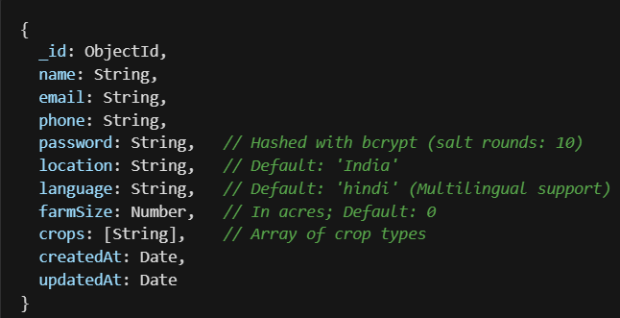

24
Machinery Collection:
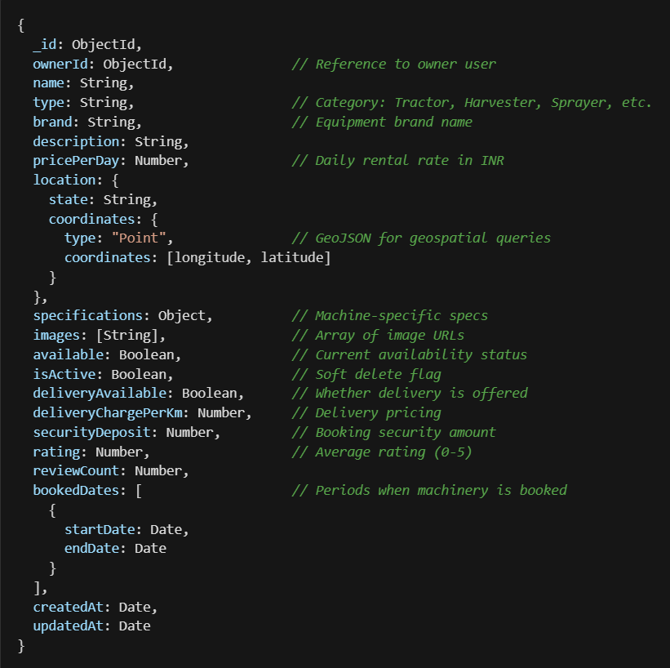

25
Bookings Collection:
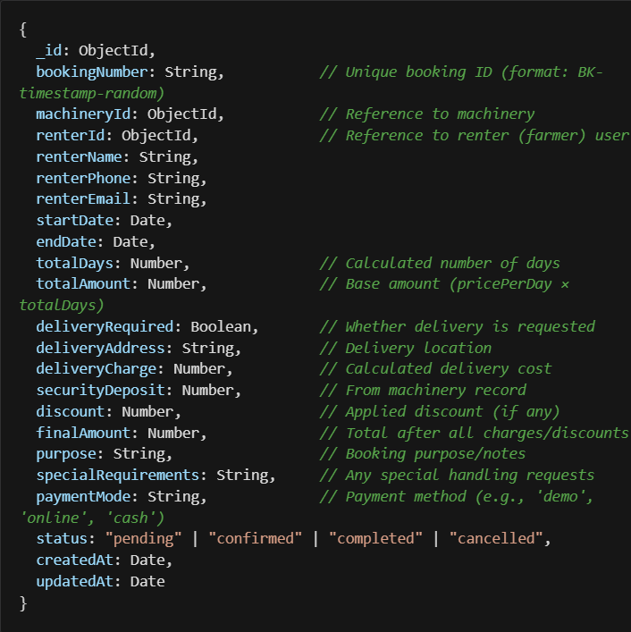

26
5.4.7 API Design
5.4.7.1 RESTful API Endpoints

Endpoint | Method | Description
/api/auth/register | POST | User registration
/api/auth/login | POST | User authentication
/api/auth/me | GET | Get current logged-in user
/api/users/:id | PUT | Update user profile
/api/machinery | GET | List all machinery with filters
/api/machinery/:id | GET | Get machinery details
/api/machinery | POST | Add new machinery
/api/machinery/:id | PUT | Update machinery
/api/machinery/:id | DELETE | Delete machinery
/api/bookings | GET | Get bookings
/api/bookings | POST | Create booking
/api/bookings/user/:userId | GET | Get user's bookings and history
/api/bookings/:id/status | PUT | Update booking status
/api/reviews | GET/POST | Get reviews / Submit review
/api/reviews/machinery/:machineryId | GET | Get all reviews for machinery
/api/messages | GET/POST | Get messages / Send message
/api/messages/conversation/:userId/:otherUserId | GET | Get conversation with specific user
/api/weather/forecast | GET | Get weather forecast data

27
5.4.7.2 External API Integrations
- Supported AI Providers:
- Groq LLM : Model: meta-llama/llama-4-scout-17b-16e-instruct (vision) and llama-3.3-70b-versatile (text); supports crop disease detection and multilingual chatbot via OpenAI-compatible endpoints with structured JSON responses.
- Google Gemini Vision AI : Model: gemini-2.5-flash (vision) and gemini-2.5-flash-lite (text); supports vision and text generation via generateContent with structured JSON schema responses when configured.
- WeatherAPI.com:
- Endpoint: /v1/forecast.json
- Parameters: location, days, uv, alerts
- Response: Current conditions + forecast
5.4.7.3 Security Implementation
Security Measure | Implementation
Password Hashing | bcrypt with salt rounds (10)
API Authentication | JWT tokens (7-day expiry)
CORS Protection | Open CORS policy (Allow-Origin: *)
Input Validation | TypeScript interface validation
API Key Protection | Environment variables (.env)

5.4.8 User Interface Design
5.4.8.1 Design Principles
- Simplicity: Clean, uncluttered interfaces with clear navigation
- Accessibility: Large touch targets, high contrast, voice alternatives
- Responsiveness: Mobile-first design for smartphone access
- Localization: Support for regional languages and cultural context
- Visual Hierarchy: Important actions prominently displayed

28
5.4.8.2 Key UI Components
Component | Purpose | Design Considerations
Navigation | Page access | Header navigation for desktop,  hamburger menu for mobile
Cards | Information display | Visual hierarchy, scannable content
Forms | Data input | Large inputs, clear labels, validation feedback
Modals | Focused actions | Overlay with clear close options
Alerts | Notifications | Color-coded severity indicators

5.4.8.3 Color Scheme
Color | Usage | Hex Code
Primary Green | Actions, success | HSL(120 45% 35%)
Warning Yellow | Alerts, caution | HSL(45 90% 55%)
Danger Red | Errors, high severity | HSL(0 84% 60%)
Info Blue | Information, links | HSL(90 35% 75%)
Background | Page background | HSL(120 25% 97%)
Text Primary | Main content | HSL(120 15% 15%)
5.4.9 Testing Strategy
Testing Type | Tools | Coverage
Manual Testing | Browser DevTools | Component  functionality
API Testing | Postman, Thunder Client | API endpoints
Usability Testing | Manual user testing | UX validation

29
6.RESULT

This image shows the FarmConnect homepage, featuring the platform’s AI-powered farming assistance, multilingual support, and quick access to major features.

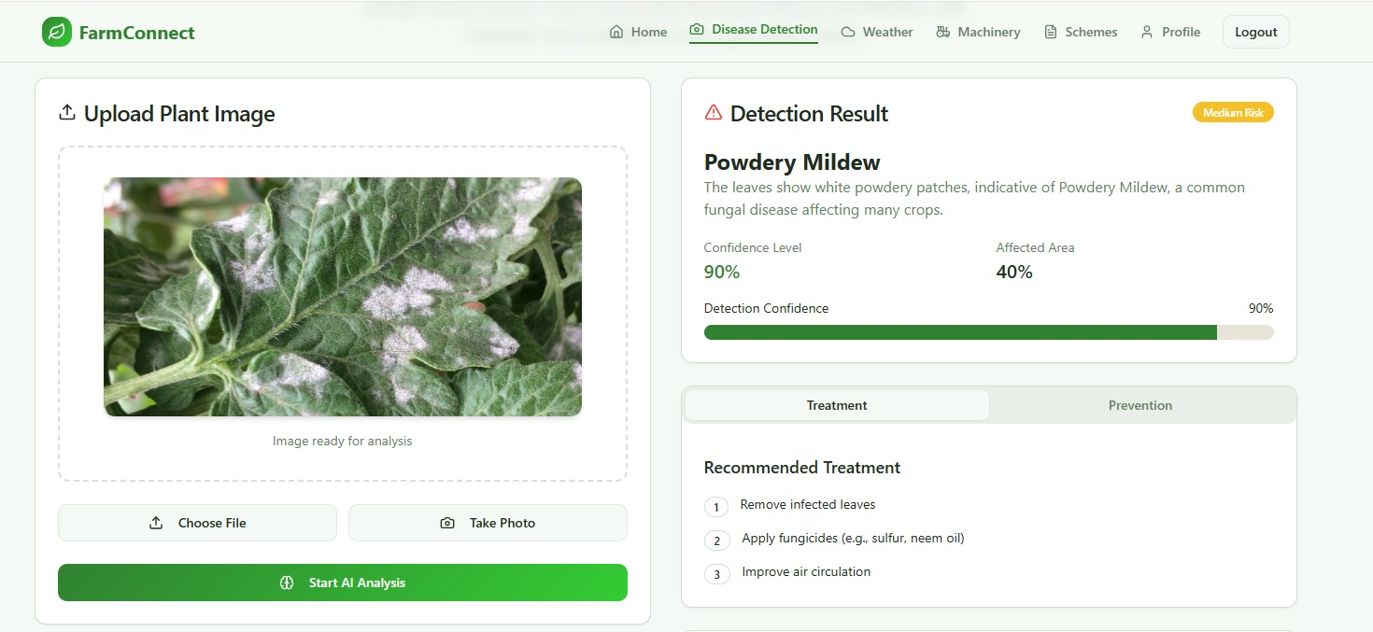

This image displays the AI Disease Detection module, where farmers can upload crop images and instantly get disease identification, confidence levels, and treatment suggestions.

30

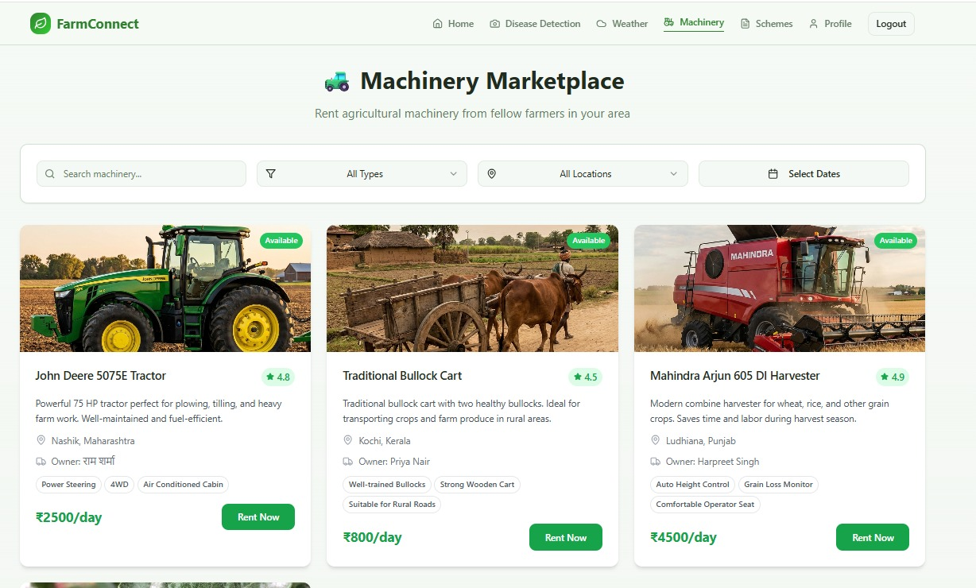

The screenshot highlights the Machinery Marketplace, allowing farmers to browse, compare, and rent agricultural machinery from nearby locations.

31

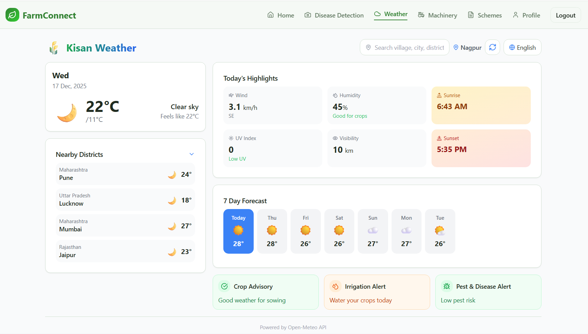

This image shows the Weather Dashboard, providing real-time weather updates, rain forecasts, alerts, and personalized irrigation and crop protection advice.

32

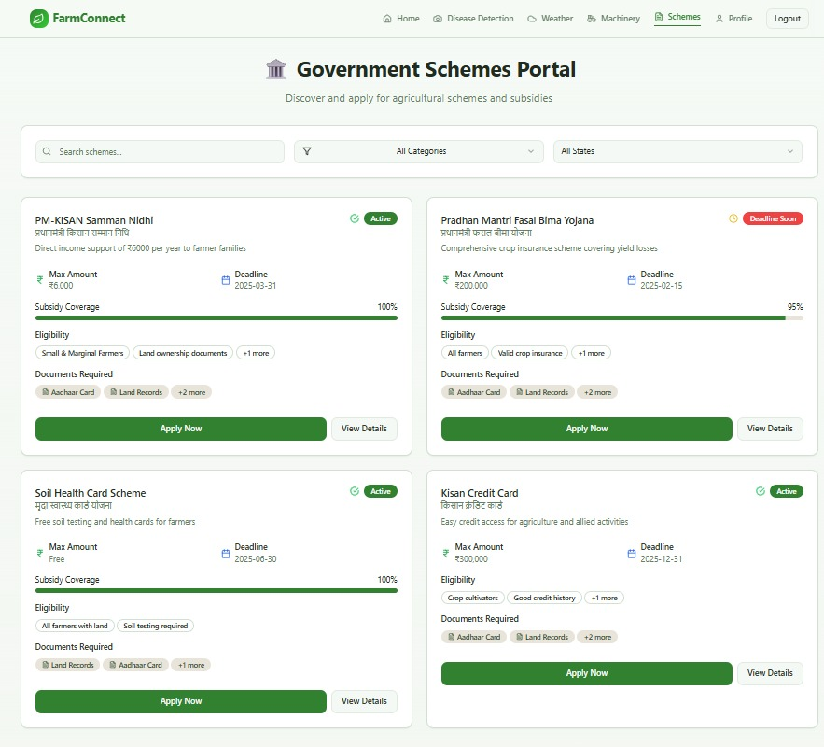

The screenshot displays the Government Schemes Portal, where farmers can discover, check eligibility, and apply for various agricultural schemes and subsidies.

33

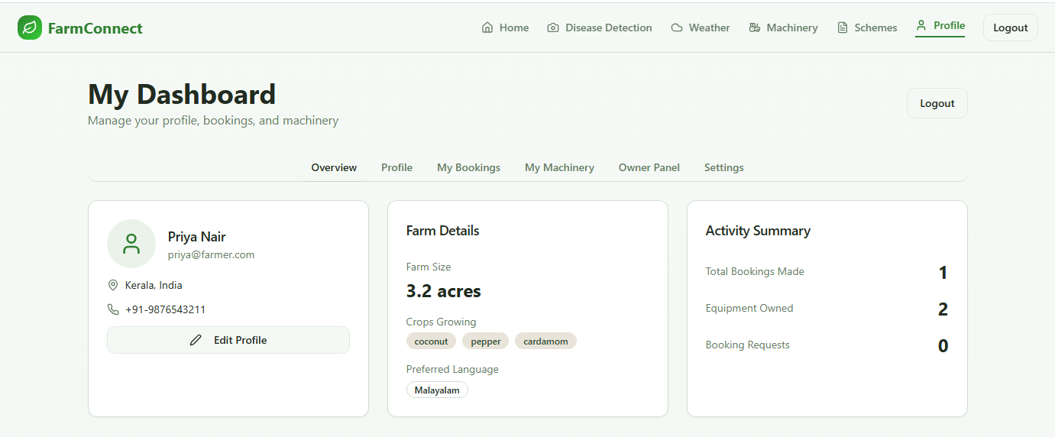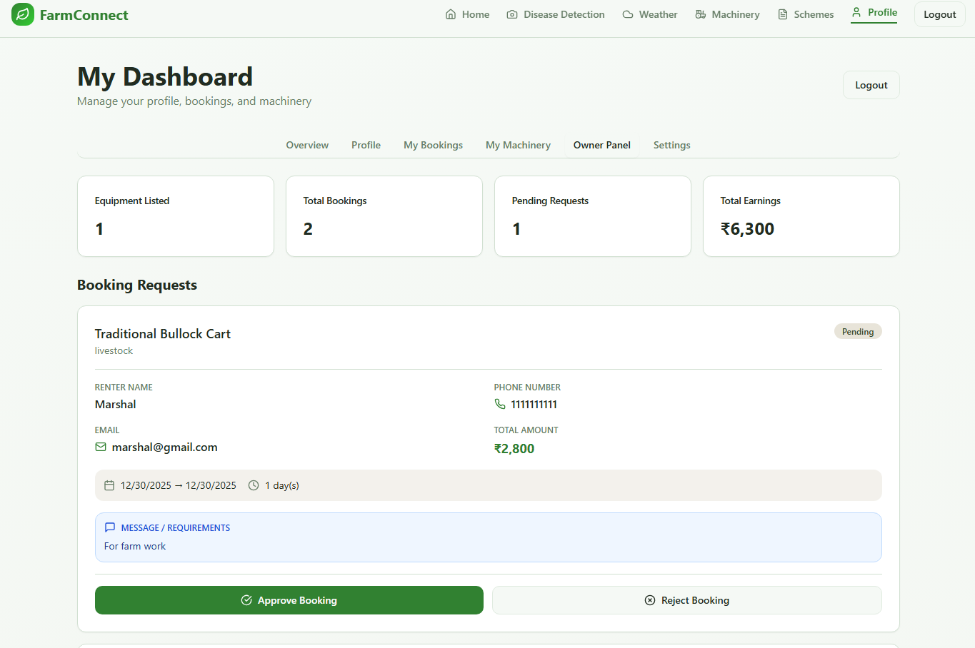

34

7.FACILITIES REQUIRED:
7.1 Hardware Requirements
7.1.1 For Development Team
Component | Minimum Specification | Recommended Specification
Processor | Intel Core i5 (8th Gen) | Intel Core i7/AMD Ryzen 7
RAM | 8 GB DDR4 | 16 GB DDR4
Storage | 256 GB SSD | 512 GB SSD
Display | 1080p Full HD | 1440p+ with accurate colors
Network | Stable broadband (10 Mbps) | High-speed fiber (50+ Mbps)

7.1.2 For Testing Devices
Device Type | Specifications
Android Smartphones | Android 7.0+, 2GB+ RAM, Chrome browser
iOS Devices | iOS 13+, Safari browser
Tablets | 8"+ screen, any modern browser
Desktop/Laptop | Any modern browser (Chrome, Firefox, Edge)

7.1.3 For End Users (Farmers)

Component | Minimum Requirement
Smartphone | Android 7.0+ or iOS 13+
RAM | 2 GB minimum
Storage | 100 MB free space for PWA
Camera | 5 MP+ for disease detection photos
Internet | 3G/4G mobile data or WiFi

35
7.1.4 Server Infrastructure

Component | Specification
Backend Hosting | Render (Node.js server)
Frontend Hosting | Vercel
Database | MongoDB Atlas (Cloud)
CDN | Cloudflare or similar
SSL | HTTPS encryption

7.2 Software Requirements
7.2.1 Development Tools
Category | Tools
Code Editor | Visual Studio Code
Version Control | Git, GitHub
API Testing | Postman, Thunder Client
Design | Canva, Figma, Draw.io, Lucidchart
Browser DevTools | Chrome DevTools, React DevTools

7.2.2 Programming Languages & Frameworks

Layer | Technology | Version
Frontend Language | TypeScript | 5.x
Frontend Framework | React.js | 18.x
Build Tool | Vite | 5.x
CSS Framework | Tailwind CSS | 3.x
UI Components | Shadcn/UI, Radix UI | Latest
Backend Runtime | Node.js | 18.x+
Backend Framework | Express.js | 4.x
Database | MongoDB | 6.x

36

7.2.3 Libraries & Packages

Package | Purpose
Axios | HTTP requests
react-router-dom | Client-side routing
@tanstack/react-query | Server state management
react-hook-form | Form handling
Bcrypt | Password hashing
Jsonwebtoken | JWT authentication
lucide-react | Icon library
Recharts | Data visualization
openai | Groq LLM API integration
@google/genai
  Google Gemini AI integration

7.2.4 External APIs & Services

Service | Purpose | Provider
AI/Vision API | Disease detection  (image analysis) | Groq LLM / Google Gemini AI  (gemini-2.5-flash, gemini-2.5-flash-lite)
Weather API | Real-time weather data | WeatherAPI.com
Speech Recognition | Voice input (STT) | Web Speech API (browser native)
Speech Synthesis | Voice output (TTS) | Speech Synthesis API (browser native)
Database Hosting | Cloud MongoDB | MongoDB Atlas
Deployment | Web hosting | Render (backend) / Vercel (frontend)

37

8. PLAN OF WORK:

Sr. No. | Phase | Activities | Timeline
1 | Topic Selection & Analysis | Selecting project theme, understanding farmer problems, identifying scope and objectives | Aug 2025
2 | Literature Review | Studying research papers, agricultural platforms, government schemes, market systems | Aug-Sep 2025
3 | Requirements Gathering | Collecting feature requirements, user needs through surveys and interviews | Aug-Sep 2025
4 | Requirements Analysis | Analyzing requirements, identifying modules, preparing flowcharts | Sep 2025
5 | SRS Documentation | Finalizing functional/non-functional requirements, completing documentation | Sep 2025
6 | System Design | Designing architecture, DFDs, module interactions, technology selection | Sep-Oct 2025
7 | Dataset Collection | Gathering weather data, market data, crop disease information from APIs | Oct-Nov 2025
8 | AI Integration | Integrating AI providers (Groq default, Gemini optional), implementing disease detection logic | Oct-Dec 2025
9 | Prototype Development | Building React frontend, implementing core features (login, dashboard, weather) | Nov-Dec 2025
10 | Testing & Documentation | Preparing reports, testing, creating presentation materials | Dec 2025-Jan 2026

38
9.REFERENCES

[1] A. Saini et al., “Smart crop disease monitoring system using deep learning in IoT,” Scientific Reports, vol. 15, Art. no. 85486, 2025.

[2] Taylor & Francis Online, “A user-centred future for agricultural digital innovation,” Journal of Agricultural Education and Extension, vol. 31, no. 2, pp. 156–172, 2025.

[3] STM Journals, “Automated crop disease detection using convolutional neural networks,” International Journal of Cheminformatics, vol. 3, no. 2, pp. 7–15, 2025.

[4] International Journal of Research Publication and Reviews, “Mobile applications for farmers: A digital revolution in agriculture,” vol. 6, no. 1, Art. no. 37720, 2024.

[5] Y. Durán, “Socio-technical transitions and sustainable agriculture,” Frontiers in Sustainable Food Systems, vol. 7, Art. no. 1145263, 2023.

[6] AJAEES Journal, “Impact of digital technologies in agricultural extension,” American Journal of Agricultural Economics and Environmental Sciences, vol. 5, no. 8, pp. 1–15, 2023.

[7] S. Coggins et al., “How have smallholder farmers used digital extension tools? A mixed-methods study in Bihar, India,” PLOS ONE, vol. 17, no. 9, Art. no. e0269661, 2022.

[8] Press Information Bureau, Government of India, “Kisan Credit Card (KCC) scheme,” 2022.

[9] A. Khattab et al., “An IoT-based cognitive monitoring system for early plant disease detection,” Computers and Electronics in Agriculture, vol. 153, pp. 194–204, 2019.

[10] A. Kamilaris, A. Kartakoullis, and F. X. Prenafeta-Boldú, “A review on the practice of big data analysis in agriculture,” Computers and Electronics in Agriculture, vol. 143, pp. 23–37, 2017.

[11] S. Wolfert, L. Ge, C. Verdouw, and M.-J. Bogaardt, “Big data in smart farming – A review,” Agricultural Systems, vol. 153, pp. 69–80, 2017.

39

[12] J. Lowder, J. Skoet, and T. Raney, “The number, size, and distribution of farms, smallholder farms, and family farms worldwide,” World Development, vol. 87, pp. 16–29, 2016.

[13] MeasuringU, “Measuring usability with the system usability scale (SUS),” 2011. [Online]. Available: https://measuringu.com/sus/

[14] E. M. Rogers, Diffusion of Innovations, 5th ed. New York, NY, USA: Free Press, 2003.

[15] V. Venkatesh and F. D. Davis, “A theoretical extension of the technology acceptance model: Four longitudinal field studies,” Management Science, vol. 46, no. 2, pp. 186–204, 2000.

[16] W. H. DeLone and E. R. McLean, “Information systems success: The quest for the dependent variable,” Information Systems Research, vol. 3, no. 1, pp. 60–95, 1992.

[17] F. D. Davis, “Perceived usefulness, perceived ease of use, and user acceptance of information technology,” MIS Quarterly, vol. 13, no. 3, pp. 319–340, 1989.

[18] Department of Administrative Reforms and Public Grievances, Government of India, “e-National Agriculture Market (eNAM),” n.d.

[19] E. Edim and H. N. Muyingi, “Speech user interface for low-literacy users of ICT services,” University Technical Publication, n.d

40

Prof. Tejas Dhule | Prof. Nishchint Makode | Dr. Shrikant Zade
Project Guide | Project Co-Cordinator | HOD. CSE

41

